SYMPTOTRACKAI: HYBRID RAG BASED SYMPTOM TRACKING AND HEALTH MONITORING SYSTEM
Scope and Limitations
Department of Computer Science and Engineering, TKR College of Engineering & Technology
Batch C12 (CSE-C) · Academic year [ACADEMIC YEAR]
Table 1: Project team
S.No. | Student name | Roll number
1 | Mariyada Karthika Reddy | 23K91A05E9
2 | Nacharam Akshaya | 23K91A05G6
3 | Madoori Prabath Teja | 23K91A05D6
4 | Pulimadhi Keerthan | 23K91A05K1

Project guide: Dr. Ch. B. Naga Lakshmi
Chapter and section numbers quoted in the text (for example Chapter 8 or Section 6.2) refer to the full project report, 17.Final Document. Figures and tables in this document are numbered from 1.

1. SCOPE

1.1 In scope
• Free-text symptom input of 3 to 2000 characters, normalised and expanded locally.
• Retrieval over a knowledge base of 176 records for 30 common conditions, with hybrid fusion and reranking.
• A grounded answer, ranked evidence cards with symptoms, description, guidance, severity and red flags, and a match indicator.
• Emergency and caution banners and a permanent not-a-diagnosis disclaimer.
• Registration, sign-in and sign-out; a private consultation history with search, detail view and deletion.
• A React interface with light and dark themes and phone-width layouts; Docker files and a one-click run.bat for Windows.

1.2 Out of scope
• Diagnosis, triage decisions, prescriptions or any clinical use; the application states that it gives preliminary information only.
• Trend analysis, timelines, symptom scoring or alerts over a user's history (objective 5 is met only as storage).
• Medical images, laboratory reports, wearable data, voice input and languages other than English.
• Clinician accounts, sharing of records, e-mail, notifications and any cloud service.
• Training or fine-tuning any model; the three models are used as published.

1.3 Users and platform
The intended user is a member of the public who wants preliminary information before seeing a professional, and an examiner or developer who explores the pipeline. The application runs on a Windows PC with Python 3.10 or newer and Node.js 18 or newer; it was measured on a CPU-only machine (12th Gen Intel Core i5-12500 (6 cores / 12 threads), no GPU, 15.7 GB).

2. ASSUMPTIONS

2.1 Assumptions
• The user describes symptoms in English, in plain words, and is the person who has them.
• The knowledge base covers the condition: the pipeline always returns the nearest records, whether or not the right condition is present.
• The application runs on a trusted machine; the secret key and the database file are protected by the operating system.
• The three models can be downloaded once; afterwards the application is offline-capable.
• A single user session at a time is typical; no concurrency requirement was set.

3. LIMITATIONS

3.1 Limitations
1. Synthetic knowledge base. 176 records written by the team, one description per condition; no public dataset, no clinical review. Scores describe lookup in this table, not medical accuracy (Chapter 8).
2. Evidence cards are near-duplicates. Mean distinct conditions among the five records: 1.2 on lay probes. The list is not a differential.
3. The relevance indicator is relative. The top record is always 100% and all 15 out-of-knowledge-base complaints were labelled Strong match; the system cannot abstain.
4. The local generator echoes its prompt in the tested environment (30 of 30 answers; transformers 5.20.2); answers come from the fallback template.
5. Safety rules are wording-bound. Recall 67.5% on 40 emergencies, 0 of 12 paraphrased ones; 6 of 10 hard negatives raised a false alarm; the answer filter is case-sensitive.
6. No symptom tracking over time. The history is a list; there are no trends or progression.
7. No per-statement citations and no judgement of groundedness by humans or a model.
8. Hardware. On a CPU the cross-encoder costs about 555 ms per query and the first request loads the models (about a minute).
9. Single-user scale. SQLite, one process, no concurrency or load testing; the signing key defaults to a development value that must be changed for any shared use.
Two figures illustrate the limitations that matter most for reading the numbers. The first shows the composition of the synthetic knowledge base: thirty conditions, four to six near-identical records each, so retrieval accuracy measured on it is an optimistic figure. The second shows what the rule-based safety layer does with emergency descriptions worded like its rules and with everyday paraphrases of the same emergencies.
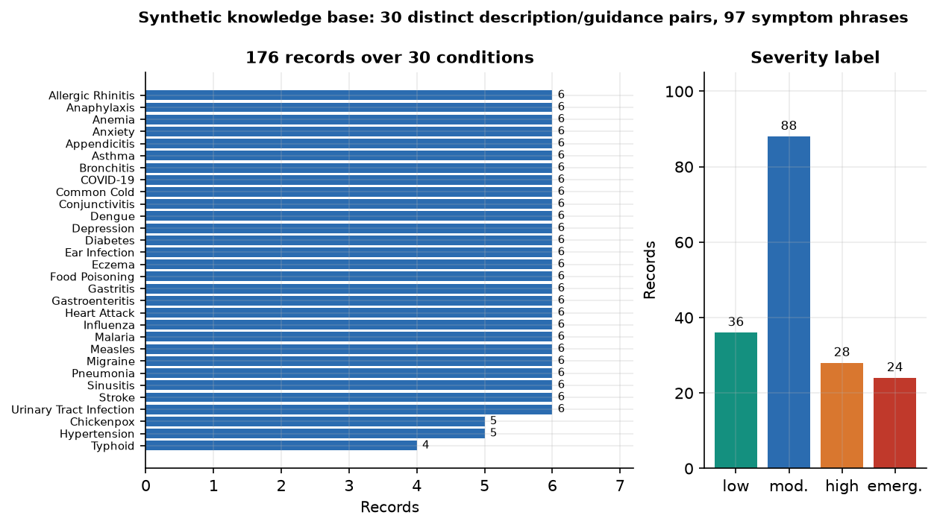
Figure 1: Composition of the synthetic knowledge base: records per condition and severity (limitation: synthetic, not clinically curated).
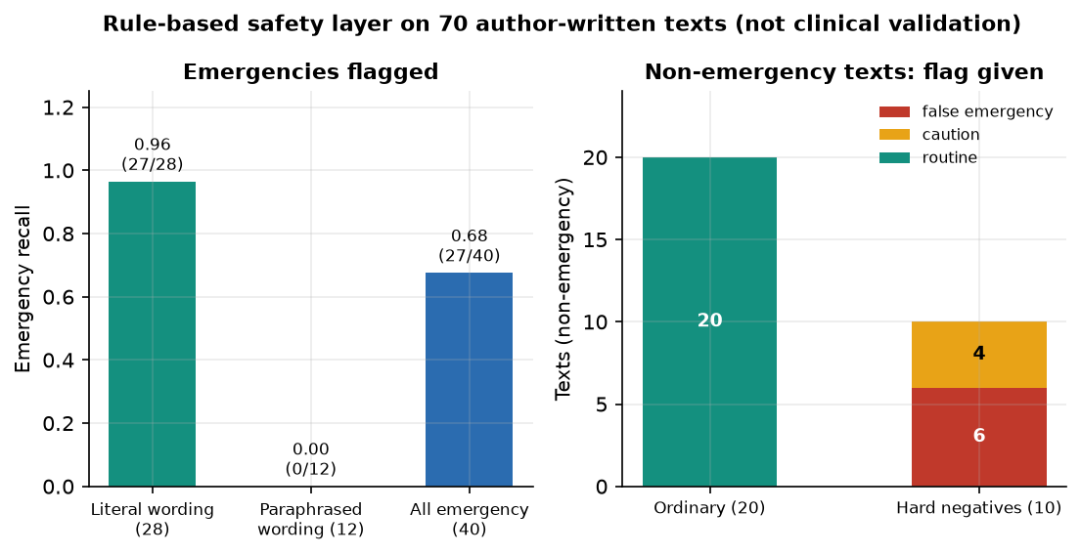
Figure 2: Safety rule layer on author-written probes: literal wording is detected, paraphrases are not, and negations cause false alarms.

4. WHAT WAS NOT MEASURED

4.1 What was not measured
• Clinical accuracy on real patient descriptions or a licensed medical knowledge base.
• Answer quality or groundedness as judged by clinicians or by a model; any user-study measure such as trust, comprehension or time saved.
• Retrieval accuracy as a function of knowledge-base size; only 176 records were available.
• Throughput, concurrency and memory under load; cold-start time was measured once.
• Browser accessibility and compatibility beyond the Chrome captures; mobile behaviour was seen only at one phone width.
• The behaviour of the generator under transformers 4.x, where the text2text-generation task exists.

